**Advance Excel Assignment 8**

1. What do you mean by AutoComplete feature in Excel and what are the benefits of using this feature?

Ans. AutoComplete helps you quickly insert functions and arguments while minimizing typing and syntax errors. The AutoComplete menu shows you available options based on context, and you choose what you want to insert into your formula.

Turn on AutoComplete :

* On the Excel menu, click Preferences.
* Under Formulas and Lists, click AutoComplete.
* Select the Show AutoComplete options for functions and named ranges check box.

1. Explain working with workbooks and working with cells.

Ans. An Excel file, often referred to as a workbook, contains one or more spreadsheets, or worksheets. Each box in the worksheet area is referred to as a cell. Each cell has a celladdress, which is composed of a column reference and a row reference. The letters across the top of the worksheet make up the column reference. The numbers down the left side of the worksheet make up the row reference. For example, the address of the top, leftmost cell is A1. This is because the cell is located at the intersection of the A column and row 1.

1. What is fill handle in Excel and why do we use it?

Ans. Fill Handle is a feature in Excel that enables you to auto-complete a list in a row/column by simply dragging it using your mouse. A basic understanding of fill handle in Excel could save you some time and make you more productive.

‘Fill Handle’ is a tool that you can use to autocomplete lists in Excel.

Follow these steps:

* Select the cell that has the formula you want to fill into adjacent cells.
* Rest your cursor in the lower-right corner so that it turns into a plus sign (+), like this:

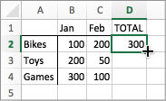

* Drag the fill handle down, up, or across the cells that you want to fill.

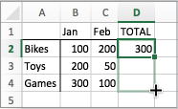

* When you let go, the formula gets automatically filled to the other cells:

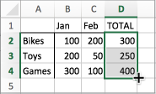

* To change how you want to fill cells, click the Auto Fill Options button that appears after you finish dragging, and pick the option that want.

1. Give some examples of using the fill handle.

Ans. Example 1 :

Autofill Numbers that Increment/Decrement by 1

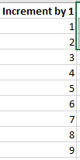

Example 2 :

Autofill Weekday Names

0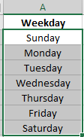

Example 3 :

Autofill Dates

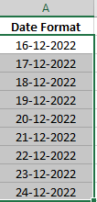

1. Describe flash fill and what the different ways to access the flash fill are.

Ans. Flash Fill automatically fills your data when it senses a pattern. For example, you can use Flash Fill to separate first and last names from a single column, or combine first and last names from two different columns.

Let's say column A contains first names, column B has last names, and you want to fill column C with first and last names combined. If you establish a pattern by typing the full name in column C, Excel's Flash Fill feature will fill in the rest for you based on the pattern you provide.

1. Enter the full name in cell C2, and press ENTER.
2. Start typing the next full name in cell C3. Excel will sense the pattern you provide, and show you a preview of the rest of the column filled in with your combined text.
3. To accept the preview, press ENTER.

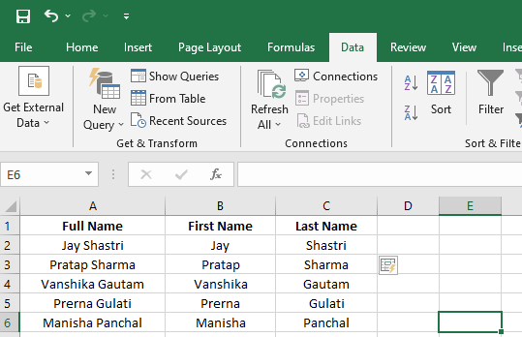

1. Extract first name and last name from the mail id and then from the address column, extract the city, state, and pin code using the flash fill. Given below is an example of the columns you have to create. Paste the screenshot of what you have created using the flash fill command.

Example: Mail Id, Address, First name, Last name, State, City, Pincode

Ans.

